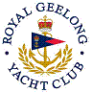 | Royal Geelong Yacht Club Inc.  Est 1859
Trophy Deed of Gift.

Trophy: | Wilfred Libby Memorial Cup
Presented by: | RGYC Club Members
Date: | 1946
For: | Event so named
Remarks / Revisions | Member in 1920’s => 1930’s. Passed away in 1945  Owner of S.J.S.
Click here to View Recipients

Wilfred Libby’s father, William established a tent. tarpaulin and sail-making business in Yarra St in about 1900. The business remained in the Libby family until about 2015.
Wilfred was one of the more iconic members of the Libby family over four generations, owning boats which included S.J.S.
Wilfred won the Hitchcock Shield seven times in SJS

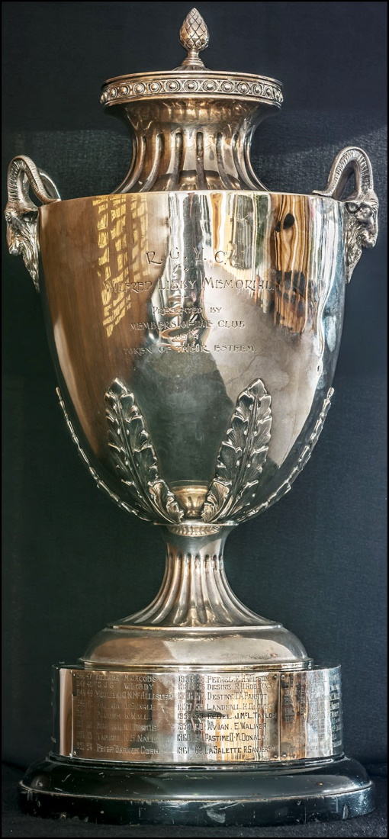

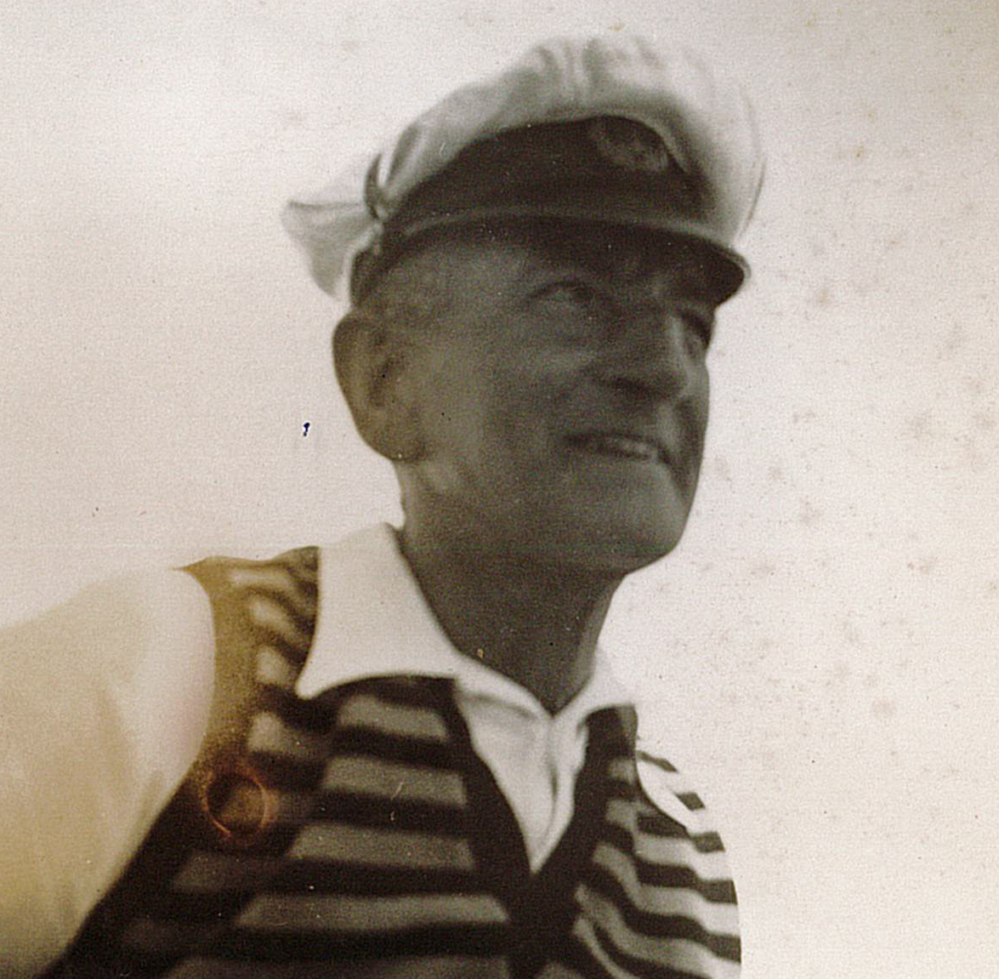

Wilfred Libby

